Name: ________________________________ Date: _________________ Block: _____
Presentation 1: The Constitutional Compromises

CONNECTICUT COMPROMISE (GREAT COMPROMISE)
The Two Plans

New Jersey Plan
- Supported by smaller states
- One house legislature
- Equal representation in Congress
Virginia Plan
- Supported by larger states
- Two house legislature (bicameral)
- Representation based on population

vs

The Solution
The Great Compromise
- Two house legislature (bicameral)
- Equal representation in the upper house (Senate)
- Representation in the lower house of Congress (House of Representatives) to be based on population

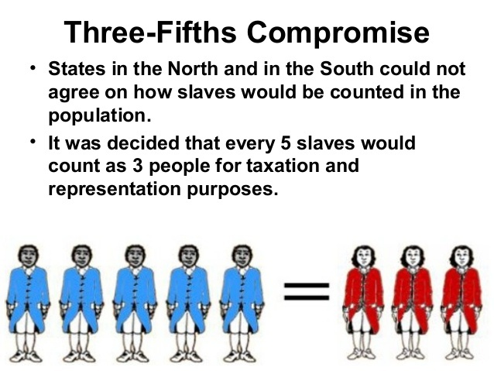
THREE-FIFTHS COMPROMISE

The Big Picture: How Slaves would be counted in the population for tax purposes and representation
 | Wanted slaves counted for taxes | Wanted slaves counted for representation
North | Yes | No
South | No | Yes

Solution: For every _____ slaves, _____ would be counted for both representation in Congress (the House of Representatives) and for taxes the states would owe the federal government.

THE COMMERCE CLAUSE
The Commerce Clause describes an enumerated power listed in the United States Constitution (Article I, Section 8, Clause 3). The clause states that the United States Congress shall have power "To regulate Commerce with foreign Nations, and among the several States, and with the Indian Tribes."

In other words: It gave the federal government the right to regulate trade with foreign nations AND between the states (and with the Native American tribes).

ADDRESSING WEAKNESES OF THE ARTICLES
Weaknesses of the Articles:
- No executive branch
- No judicial court system
- Single chamber of Congress
- Congress could not tax, regulate trade, or enforce laws
How the Constitution addressed the weaknesses:
- Created three branches of government:
  - executive branch- enforced laws
  - legislative branch- made the laws
  - judicial branch- interpreted the laws
- Legislative Branch was bi-cameral (two house legislature)
  - House of Representatives- based on population
  - Senate- equal representation (2 senators for each state)
- Commerce Clause provided power to Congress to oversee trade for states, foreign governments, etc.
Presentation 2: Principles of the Constitution
- Rule of Law- no one is above the law; not even the government
- Limited Government- the Constitution sets limits on the powers of the national government
- Popular Sovereignty- __________________________________________________________________________
- Separation of powers- powers and responsibilities are divided among three branches to prevent one person or group from having too much power.
- Checks and Balances- allows each branch to ____________________ and check the power of the others to prevent abuse of power.
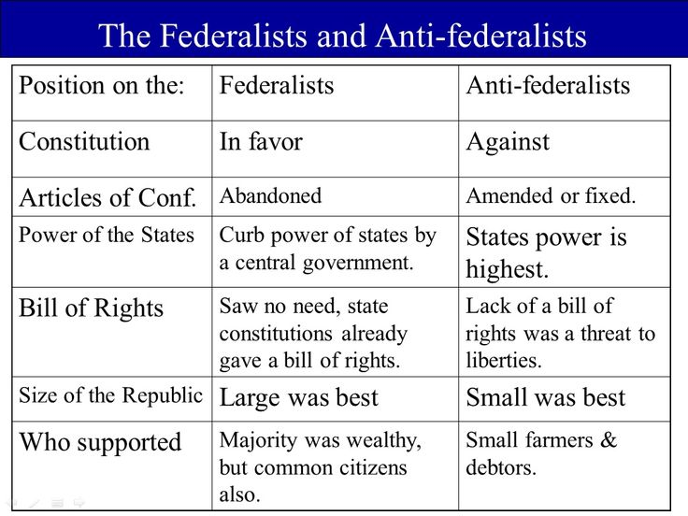
- Federalism- power is divided between the national government and the individual state and local governments
FEDERALISTS VS. ANTI-FEDERALISTS

The Federalist Papers
  - A series of 85 essays written to ____________________ the ____________________
  - Written anonymously by: ____________________ ____________________, ____________________ ____________________, and ____________________ ____________________

Federalists |  | Anti-Federalists
1. |  | 1.
2. |  | 2.
3. |  | 3.
4. |  | 4.
5. |  | 5.
6. |  | 6.

- Ratification of the United States Constitution
  - In December 1787, ____________________ became the first state to ratify the Constitution
  - In June 1788, ____________________ ____________________ became the 9th to approve the Constitution; making it the brand new “Supreme law of the land.” (They needed 9 of the 13 states to ratify)
- Adoption of the Bill of Rights
  - By December 1791, the states ratified ten of the twelve proposed amendments, which came to be known as the Bill of Rights.
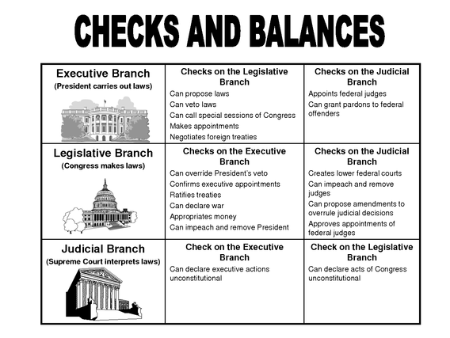
Checks and Balances / Separation of Powers
Separation of Powers

PARTS OF THE CONSTITUTION
Preamble | Introduction/ Purpose of the Constitution
Article 1 | Legislative Branch (Founding Fathers thought this was most important)
Article 2 | Executive Branch
Article 3 | Judicial Branch
Article 4 | States
Article 5 | Amendment Process
Article 6 | National Debt, Supremacy Clause, & Oath of Office
Article 7 | Ratification Process
Amendments | The listing of Amendments to the US Constitution (27 total on the list now)

TYPES OF POWERS- know the difference between these powers!
Enumerated
Implied
Concurrent
Reserved
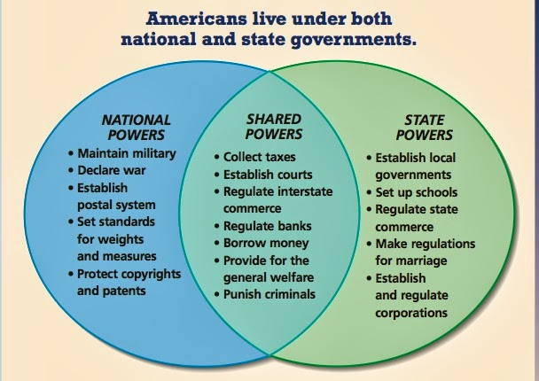
Enumerated Powers vs Implied Powers

THE SUPREMACY CLAUSE
- Says that the Constitution is the Supreme Law of the Land
- This mean that federal law ________________ all state and local laws

Necessary and Proper Clause
- In Section 8 of Article 1, the Constitution says that Congress can “________________ all ________________ which shall be necessary and proper” for carrying out its ________________
- This is also sometimes called the ________________ ________________, because it means that Congress’ powers can be ________________ to cover a variety of issues or circumstances

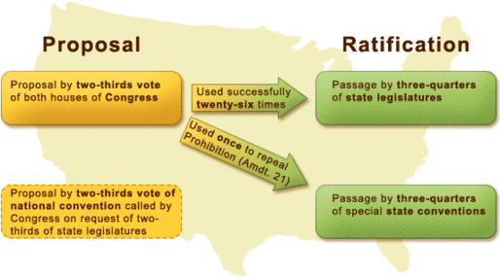
THE AMENDMENT PROCESS

- Proposal
  - You need 2/3 vote of BOTH houses of Congress OR
  - 2/3 vote of national convention called by Congress on request of 2/3 of state legislatures (this method has never been used)
- Ratification
  - Passage of 3/4 of state legislatures (used 26 times so far)
  - Passage of 3/4 of special state conventions (used once for the 21st Amendment)

THE BILL OF RIGHTS

2nd Amendment- The right to bear arms
3rd Amendment- No quartering of soldiers in private homes without the consent of the owner in times of peace.
4th Amendment- No unlawful search or seizure without a warrant or probable cause

7th Amendment- right to a jury trial in CIVIL MATTERS that exceed $20

9th Amendment- Individual Rights: rights kept by the people; protects rights not enumerated in the Constitution
10th Amendment- States’ Rights- the federal government possesses only those powers delegated to it by the states or the people through the Constitution

Civil Rights vs. Civil Liberties
- Civil liberties are protections against _______________- this means either federal or even state
- Civil rights- positive acts of government to protect our rights- our _______________ guarantee (Our protections in the BoR)
- Civil liberties are protected by the 1st Amendment and civil rights are protected by the _______________ Amendment (National government) and the _______________ Amendment (State government)
What are our rights?
- The first 10 Amendments are called the Bill of Rights (protection from _______________)
- Most rights and liberties are granted to all in the U.S. regardless of _______________
- Non-citizens cannot do the following:
  - may not _______________,
  - may not be on _______________,
  - may not hold public office or certain _______________
How is Religion Protected?
- _______________ Amendment
  - _______________ Clause
  - _______________ _______________ Clause
  - Wall of separation between church and state- Thomas Jefferson
Religion and Schools
- Everson v Bd. Of Ed. (1947)
  - Applied the Establishment Clause in the Bill of Rights to _______________ laws
- Lemon v Kurtzman (1971)
  - Created a three part _______________ test to see if states can give money to private _______________ schools
- Lemon Test
  - The statute must have a _______________ purpose
  - Its principle or primary effect must be one that neither advances nor inhibits _______________
  - The statute must not foster “an excessive _______________ entanglement with religion.”
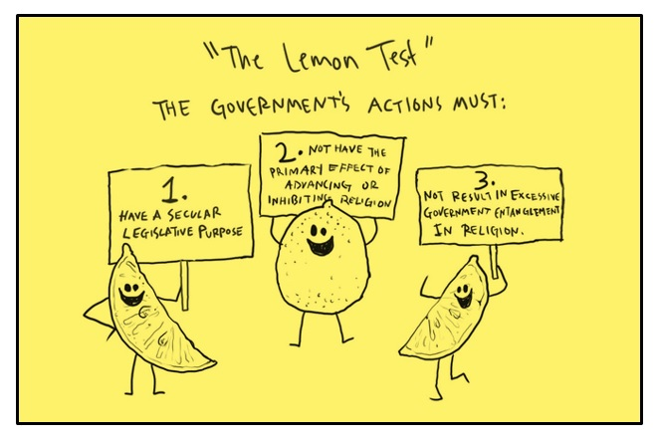
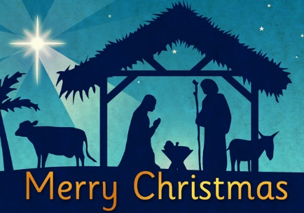
Other Issues with Establishing Religion
- Issues with seasonal themes- _______________, Hanukah, etc. at government places
- Prayers led by _______________ at government meetings
- Displaying the _______________ _______________ in front of government buildings
Freedom of Speech, Assembly, Press
- George Washington quote about freedom of speech: “If the freedom of speech is taken away then dumb and silent we may be led, like _______________ to the _______________.”
Types of Speech
- Pure Speech- communication of _______________ through _______________ or written words or through conduct limited in form to that necessary to convey the idea
- Symbolic Speech-
  - Used to describe actions that purposefully and discernibly convey a particular message or statement to those viewing it
- Texas v Johnson (1989)
  - In a _______________ decision, the Court held that Johnson’s burning of a flag was a protected expression under the _______________ Amendment.
  - The Court found that Johnson’s actions fell into the category of expressive conduct and had a distinctly _______________ nature- even if society finds it offensive
Limits on Free Speech
- Sedition- the crime of creating a _______________, disturbance, or violence against civil authority with the intent to cause its overthrow or _______________.
- Clear and Present Danger
  - Schenck v US (1919)- “The question in every case is whether the words used are used in such circumstances and are of such a nature as to create a clear and present _______________ that will bring about substantive evils that _______________ has a right to prevent.”
  - During _______________, utterances tolerable in peacetime can be punished.
- Defamation
  - Slander: the action or crime of making a false _______________ statement damaging a person’s reputation
  - Libel: a _______________ false statement that is damaging to a person’s reputation; a _______________ defamation
- Fighting Words
  - Words which would likely make the person whom they are addressed commit an act of _______________
- Chaplinsky v. New Hampshire (1942)
  - The SCOTUS established the doctrine by a _______________ decision
  - Limitation to freedom of speech as protected by the _______________ Amendment to the US Constitution
  - Fighting words are not _______________ speech
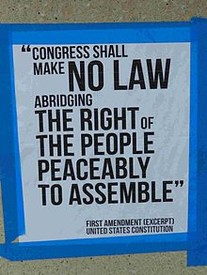
- Freedom of Assembly and Petition
  - Right to petition the government for _______________ of _______________- right to ask for government action
  - Boy Scouts of America v Dale (2000) allowed the Boy Scouts to ban _______________ from being scout leaders (personal/ private club)
  - _______________ Act restricts _______________ employees from political activities
  - Campaign contributions can be limited (person can spend on their own campaign)
  - Freedom of Assembly- government can regulate _______________, place and manner, require _______________ permits
- Freedom of Press
  - Press gets access but not all the time (Freedom of _______________ Act 1966)- allows public to view _______________ files (now can be done electronically)
  - Example: US vs _______________ (1974)
  - Gag orders- cannot speak about trials or _______________
  - Shield laws- protection for the press; do not have to reveal their _______________
  - Miller v. CA (1973)- _______________ material is not protected by the 1st Amendment
Civil Rights & Equality
- Equality
  - One of the founding principles of our _______________
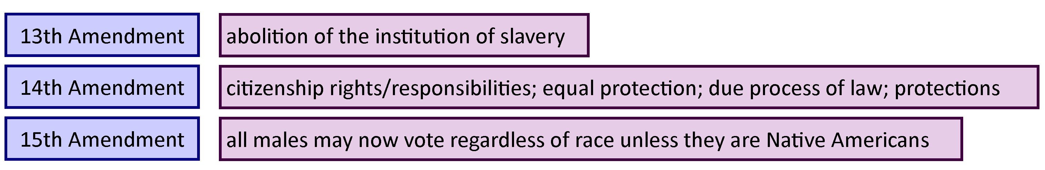
  - All citizens are guaranteed _______________ protection under the law
- NOTE: The 14th Amendment went hand in hand with the 5th Amendment’s DUE PROCESS. Because of the 14th Amendment, all the rights and protections of the Bill of Rights were extended to ALL levels of government!

- The Struggle for Equality
  - These amendments go by two names:
    - The _______________ _______________ Amendments
    - The _______________ Amendments
  - Jim Crow Laws (Post 1877)
    - Laws passed in the South that required segregation (_______________) of blacks and whites in society
- Landmark Court Cases
  - Plessy v Ferguson (1896)
    - Established the _______________ but equal doctrine
    - _______________ Court endorsed the Jim Crow laws
    - The use of race as a criterion of _______________ in public matters was not unreasonable
    - Legalized _______________
  - Brown v Bd. Of Ed. (1954)
    - Overturned the Plessy case and ended _______________ (technically)
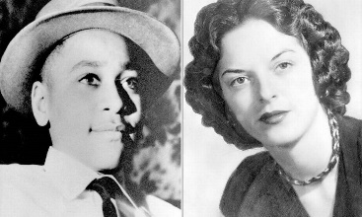
    - Emmett Till (Summer of 1955)
  - Fourteen-year-old _______________ _______________ was murdered for flirting with a white woman by giving a “wolf” whistle and saying, “Bye, baby” to the woman.
    - This brought to light brutality of Jim Crow _______________ in the South.
    - Decades later his accuser admitted that he had never done anything; she had lied about it to her husband.
- Montgomery Bus Boycott (December 1955)
  - Occurred because _______________ _______________ was arrested for refusing to give up her seat on a bus where she had been sitting in the colored section
- Little Rock Crisis (1957)
  - Occurred in Little Rock, _______________
  - The National Guard was called in to prevent _______________ by the governor; later called the Little Rock Crisis.
- Civil Rights Acts passed shortly after the Brown decision:
  - Civil Rights Act of _______________
  - Voting Rights Act of 1964
  - Civil Rights Act of _______________
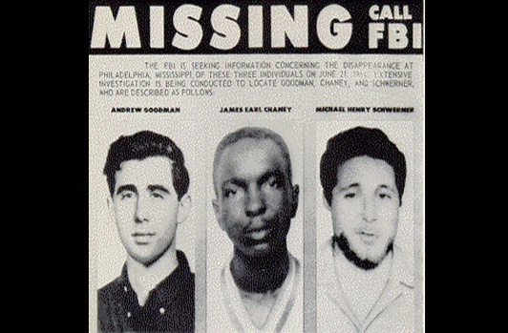
- Mississippi Burning (June 1964)
  - Three civil rights workers were murdered in Mississippi for trying to help African Americans register to _______________
  - Their bodies were found in August 1964 after FBI involvement
- Malcolm Little (Malcolm X)
  - African American Muslim minister, outspoken leader in the Nation of Islam, and _______________ _______________ activist during the 1950’s and 60’s.
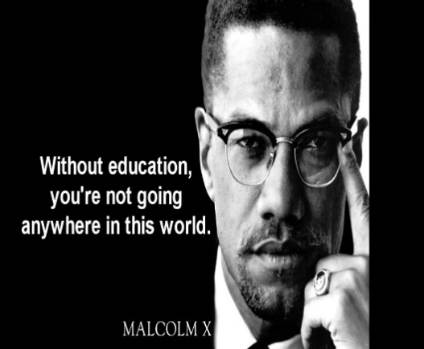
  - Clashed with MLK and the Civil Rights Movement because the Nation of Islam wanted _______________ between blacks and whites and promoted _______________ _______________ while MLK promoted _______________ and _______________.
  - Disillusionment
    - Occurred in 1962 and 1963
    - Malcolm X lost faith with the leader of the Nation of Islam, Elijah Muhammed, for _______________ _______________
    - He left in 1964 after expressing interest in working with Civil Rights leaders like _______________
  - Malcolm X Assassinated
    - Killed February 1965
    - He was assassinated by members of the _______________ of _______________ while giving a speech
    - Quote: “Education is the passport to the future, for tomorrow belongs to those who prepare for it today.”
- Affirmative Action
  - An action or policy favoring those who tend to suffer _______________; especially in relation to _______________ or _______________.
  - _______________ discrimination

