Name: _____________________________________ Date: ________________________ Block: 1st ________
Title
Why is the title of a map so important?

The 16 Point Compass Rose
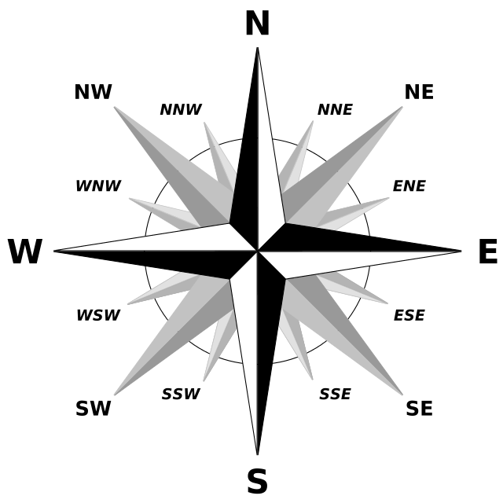
Directions: Label the compass rose below using the abbreviations for each direction.

Scale
What information does the map scale provide?

Legend/ Key
What information does the map legend or key provide?

Create a Map
Directions: On the back of this worksheet, create a map of your hometown (or other map of your choice) that includes all the elements of a map. Colored pencils are available for this activity.

