**Name: ___________________________________ Date: ____________ Block: _______**

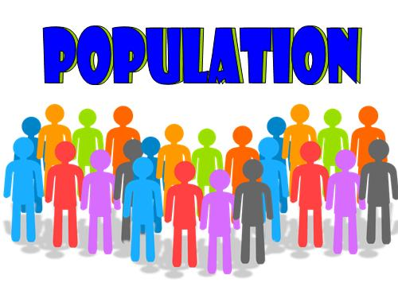**Concept 1: Distribution of Power**

1. **Features of a State**
   1. Population
      1. People share similar general beliefs
      2. Sharing basic beliefs equates into a more stable _______________
      3. Shifts in _______________ changes the power matrix

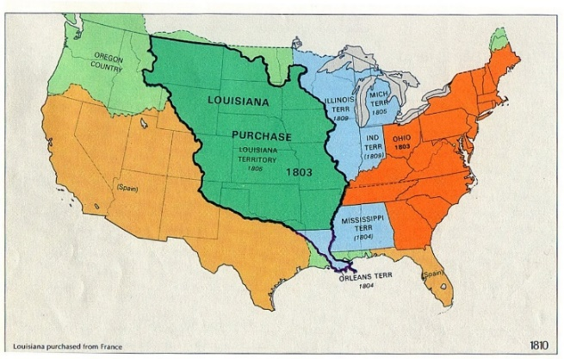

* 1. Territory
     1. Definition:
     2. Things that change fixed boundaries:
        + _______________
        + 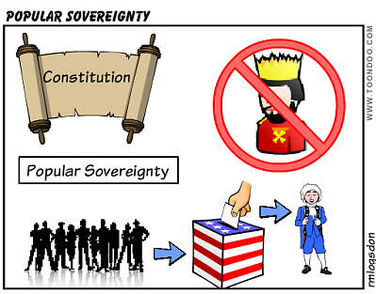_______________ (treaties)
        + _______________ purchase
  2. Sovereignty
     1. **It is the _______________ characteristic of a state**
     2. The state has supreme and _______________ authority in its boundaries
     3. It has complete independence & powers to make laws & foreign policy & determine its course of action.
     4. In theory, no state has the right to interfere with the internal affairs of another state.

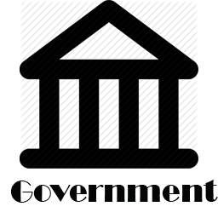

* 1. Government
     1. The institution through which the _______________ is able to perform all of its essential functions

1. **Theories of the Origin of the State**

|  |  |
| --- | --- |
| ____________________  Theory | Began with the nuclear family and evolved as the family grew |
| ____________________  Theory | People of an area are forced under the authority of one group or person who uses violence or the threat of violence to get the work accomplished. |
| ____________________  Theory | Believed they were either descendants of the people’s god(s) or chosen by the god(s) to rule the people |
| ____________________  Theory | People give the government only the power necessary to bring about and maintain order |

1. **Government Systems**

|  |  |
| --- | --- |
|  | Gives all the power to the national or central government |
|  | A loose union of independent & sovereign states |
|  | Divides the powers of the govt between the national govt and the state/ provincial governments |

* **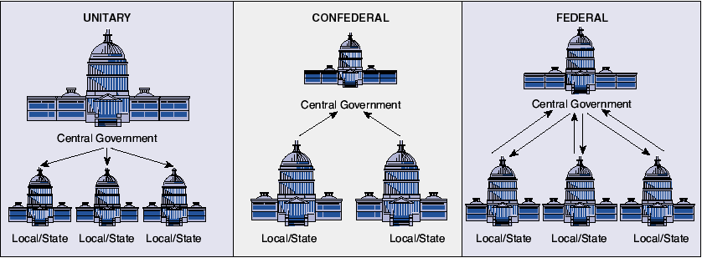*See the chart below for a representation of power flows between the levels of government.***

1. Constitutions and Government
   1. Constitution- plan that provides the _______________ for government
   2. Provides supreme law for states and their governments
2. Major Types of Government
   1. ____________________________
   2. ____________________________
   3. ____________________________
3. Authoritarian- few, if any, political freedoms
   1. Dictatorships- power is in the hands of _______________ person
   2. Totalitarian- the _______________ has total control
   3. _______________- a small group of people hold the power
4. Monarchy
   1. Form of government where a king, queen, or emperor rules the people
   2. Two types of monarchy
      1. 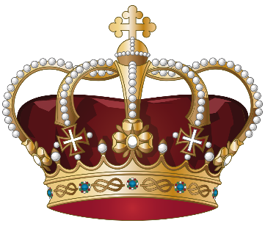_______________ monarchy- the active rule of a king or queen who shares none of the power (have absolute authority over all decisions)
         * Example: Swaziland
      2. _______________ monarchy- the king or queen is limited by the law
         * Example: England
5. Democracy
   1. The _______________ hold the sovereign power of the government
   2. Example: United States
6. Types of Democracy
   1. _______________ democracy- people decide (e.g. vote on, form consensus on) policy initiatives directly
   2. _______________ democracy- founded on the principle of elected officials representing a group of people, as opposed to direct democracy
   3. Republic- supreme power is held by the people & their elected or nominated president rather than a monarch
7. Role of the executive
   1. Parliamentary system:

______________________________________________________________

* 1. Presidential system:

______________________________________________________________

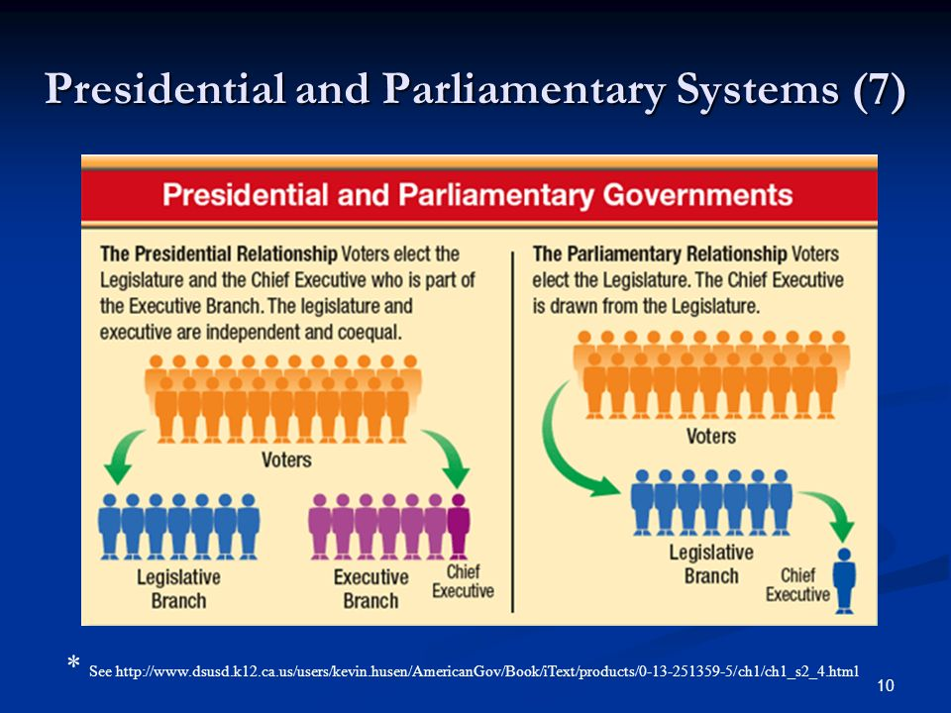

1. Principles of Democracy
   1. Citizen Participation
   2. Regular Free & Fair Elections
   3. Accepting the Results of the Elections
   4. The Rule of Law
   5. Majority Rule with Minority Rights
   6. Accountability
   7. Transparency
   8. Limited Government & a Bill of Rights
   9. Control of the Abuse of Power
   10. Economic Freedom
   11. Equality
   12. Individual/ Human Rights
   13. Independent Judiciary
   14. Competing Political Parties

**Concept 2: Limited Government and the Rule of Law**

1. ____________________ Government- political system in which powers of the government are restricted, usually by a written constitution.
2. Rule of ____________________- government is based on a clear and fairly enforced laws & no one is above the law!



1. Magna Carta **(King and Nobles agreement)**
   1. Signed by King _______________ of England in 1215
   2. This charter defined the rights and duties of English nobles and set limits on the monarch’s power
   3. This document established the **Rule of** _______________, which meant that all people, even the king, have to obey the laws.

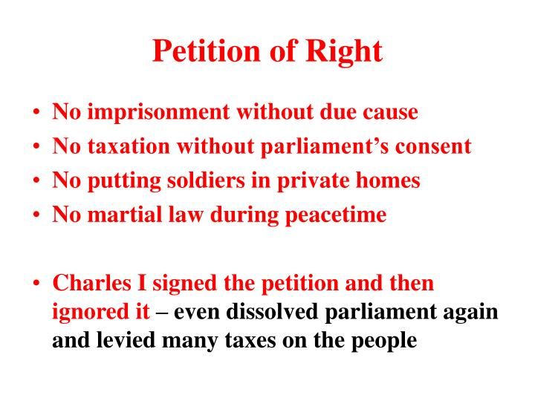

1. Petition of Rights **(Peasants get Rights! - or do they?)**
2. Law passed by English _______________ in 1628 to try and limit the power of King Charles I.
3. Extended the rights provided in the Magna Carta to the peasants
4. Charles I signed it and then ignored it by levying taxes & getting rid of Parliament **(Attempted limitation of government- not successful)**
5. 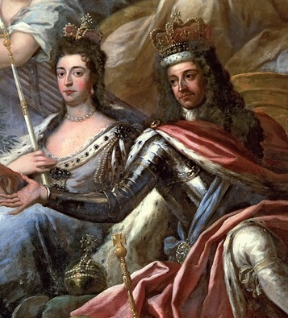English Bill of Rights
6. Passed by _______________ in 1689 after years of conflict and civil war
7. Parliament offered the throne to _______________ and _______________ of Orange, but insisted they accept the Bill of Rights as a condition of their rule.
8. 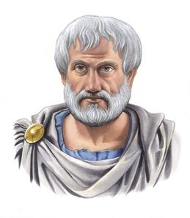Created separation of powers, limited the powers of the king and queen, and enhanced the democratic election while bolstering freedom of speech. **(Actual limitation of government)**

William & Mary of Orange

**Concept 3: Political Philosophies**

1. ____________________
   1. One of the first students of government
   2. Known as the “*father of political science*”

**Aristotle**

* 1. 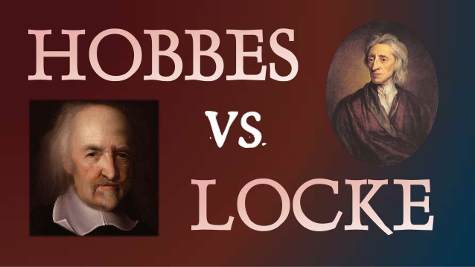Favored a constitutional government with combined principles of oligarchy & democracy as the ideal form of government

1. Thomas Hobbes
   1. Writings: _______________
   2. Principle theory: _______________ _______________
   3. People give up _______________ in exchange for _______________ from the government
   4. Quote: “It is not _______________ but Authority that makes a law.”
2. John Locke
3. Writings: _______________ _______________ on _______________
4. Principle theory: _______________ Rights (Life, Liberty, and Property)
5. Everyone has God given rights that cannot be taken away
6. Quote: “All mankind… being all equal and _______________, no one ought to harm another in his life, health, liberty, or possession.”
7. 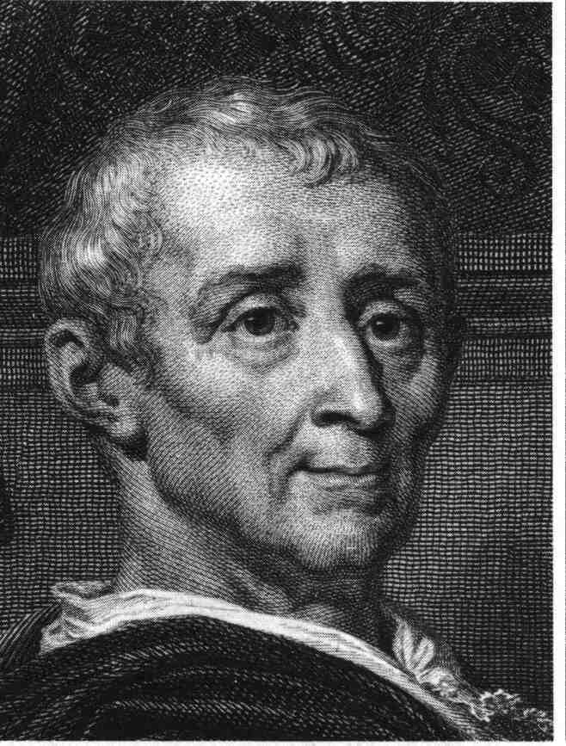Baron de Montesquieu (Charles Montesquieu)
8. Writings: The _______________ of _______________
9. Principle theory: Separation of _______________
10. Power should be divided into _______________ branches and each has a job that only it can do

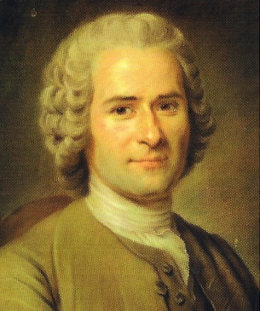

1. Jean-Jacques Rousseau
2. Writings: The Social _______________

**Montesquieu**

1. Principle theory: _______________ sovereignty
2. The government should reflect the will of the _______________

**Rousseau**

1. Formation of the United States government
2. America was originally a _______________ colony
3. The U.S. won its independence and became its own country during the American _______________
4. 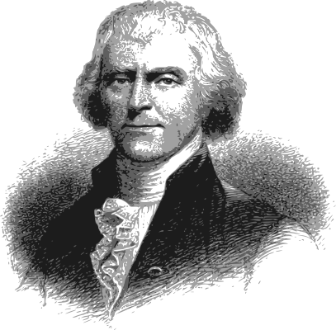The _______________ of _______________ was written and approved during the American Revolution to formally announce a separation from Great Britain.
5. Declaration of Independence
6. Written by _______________ _______________
7. Approved on July 4, 1776
8. Provides persuasive argument for why Americans want independence from the British king

**Thomas Jefferson**

1. Articles of Confederation
2. First law of the land of the _______________ _______________
3. Created a loose _______________ of states
4. 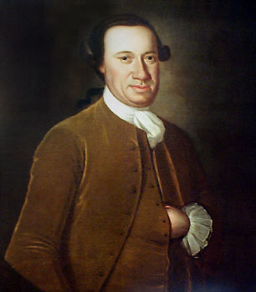First President under the Articles was John _______________ (ceremonial position)
5. Government under the Articles:
6. The nation’s first government included a _______________- chamber Congress, with limited powers

**John Hanson**

1. Each state had _______________ vote
2. It had no _______________ branch or court system
3. 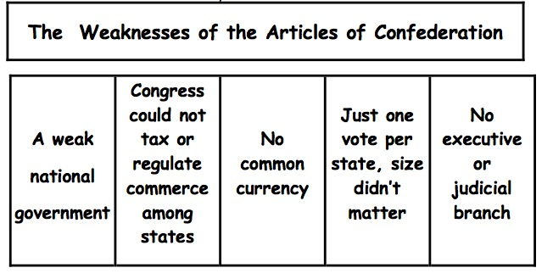Weaknesses:
4. Amending the Articles required approval of _______________ the states.
5. _______________ Rebellion
   1. Led by Daniel Shays
   2. Conflict between poor farmers and rich merchants and lawyer in Massachusetts
   3. Showed the government was too weak to handle a crisis
   4. Led to a call for a ____________________ convention to fix the problem