Unit 1: Introduction to Geography
- What does economic activity on a map of a country show?

- What are coal, iron, uranium, and petroleum?

- What do geographers call an area with one or more features that set it apart from other areas?

- The changes in shape, size, and position of features that occur when representing the Earth on a flat map take place because of

- If you were using a road map while traveling from Dallas, GA to San Francisco, CA, how could the compass rose, map key, and scale help you? (SSWG1c)

- What is the difference between absolute and relative location?

- What is the starting point for measuring lines of latitude?

- What is the starting point for longitude?

- What is the difference between weather and climate?

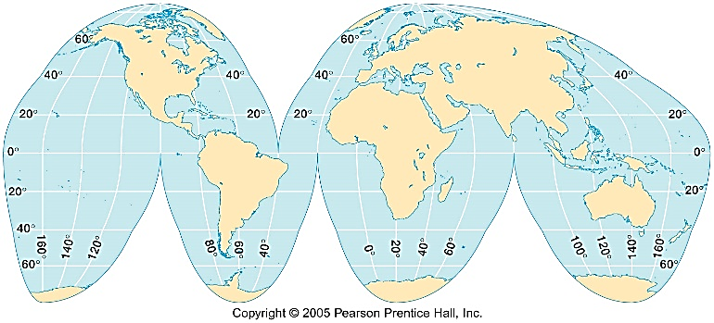

- What is the main advantage of the type of map projection shown above?

- What causes the changing of seasons throughout the year?

Unit 2: The United States and Canada
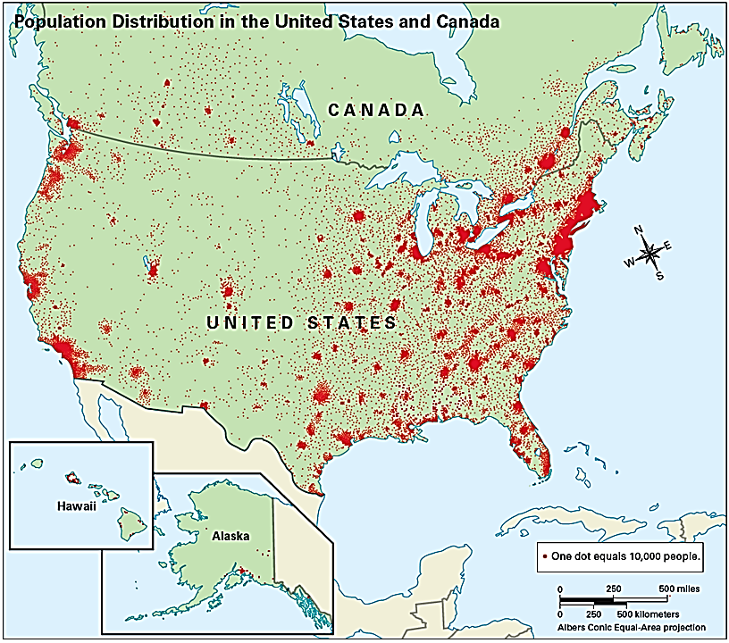
- The dark places on the map above are best defined as which of the following?

- Which term best describes people coming TO the United States FROM other countries to start new lives?

- What is the difference between push and pull factors?

- The United States and Canada fill _____ of the land surface of the Earth.

- If the United States is spending more on imports than it earns in exports, what is the result?

- Why have the Appalachian Mountains experienced far greater erosion than the Rocky Mountains?

- Which oceans border the United States and Canada?

- What countries are involved in the North American Free Trade Agreement (NAFTA)?

- Why do 90% of Canadians live on only 10% of the land?

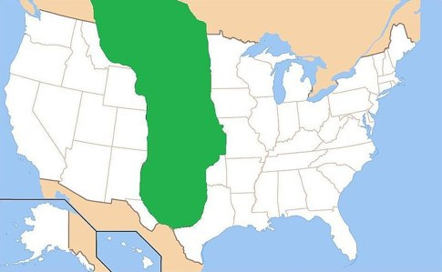
- The area shaded on the map above represents what region of the United States?

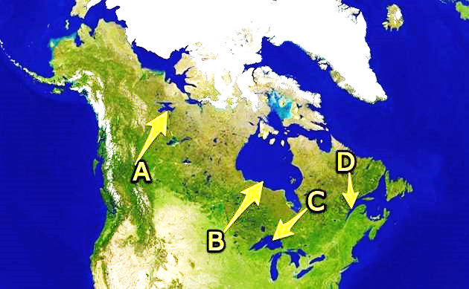

- Identify the letter that is pointing to the Great Lakes on the map above.

Unit 3: Latin America
- What language do the majority of Latin American countries speak?

- Area of grassland and rich soil that is used for cattle and wheat.

- What is the name of the river that forms the border between the United States and Mexico.

- Step-like fields cut into hillsides and mountains that allow crops to grow on steep land and cuts down on soil erosion.

- The Treaty of Tordesillas was an agreement between these two countries:

- The cutting down and clearing away of trees.

- What are the organizations that bring billions of dollars of illegal drugs into the United States?

- What major mountain range is located in South America?

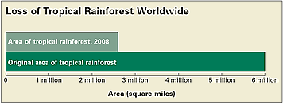
- According to the graph above, what happened to the size of the rain forest from its origination to the year 2008?

- What is the difference between a tropical storm and a tropical cyclone?

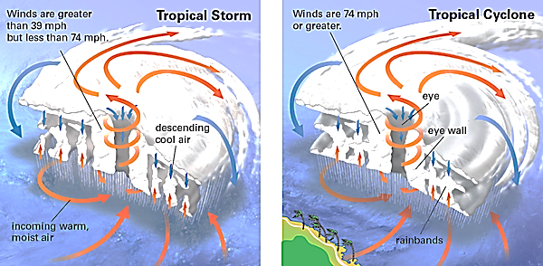
4
3
Unit 4: Europe and Russia
- A force that divides people and countries.

- Define centripetal force.

- How has the European Union (EU) promoted economic cooperation across Europe?
  - it has reduced or eliminated trade barriers
  - it has banned imports (goods from other countries)
  - it has raised workers’ salaries
  - it has ended business competition
- How is the EU able to have an open border policy among different nations?
  - developed a plural society
  - created a common form of money
  - eliminated all cultural differences
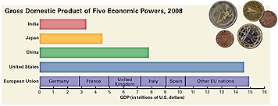
  - established a common defense organization
- What mountains form a border between Spain and France?

- Which of these statements is best supported by the information in the graph above?
  - The EU produces fewer goods and services than China.
  - The EU trades more with the US than with India.
  - The EU has almost the same economic power as the US.
  - The EU has a higher GDP than India, Japan, and China combined.
- Which of the following best describes the Northern European Plain?
  - flooding prevents the land from being cultivated
  - a lack of pesticides results in a low production
  - air and water pollution have destroyed the land
  - a variety of crops are produced in abundance

- Europe has 5 major peninsulas. What can you assume from this fact?
  - over sea/ maritime trading is important
  - plant and animal life are scarce and uniform
  - trade is difficult because of the terrain
  - written language was first developed here
- Which body of water is the deepest and oldest in the world, is one mile from the surface to the bottom at the deepest point, is 400 miles long, and holds 20% of the world’s fresh water?

- A region in Russia known for rigid temperatures and many natural resources.

- Out of the all the bodies of water discussed in Europe and Russia, which one is the best example of overuse of water in the region?

