Name: _______________________________ Date: ______________ Block: ________
Unit 1: Introduction to Geography
- What does economic activity on a map of a country show?

- What are coal, iron, uranium, and petroleum?

- What do geographers call an area with one or more features that set it apart from other areas?

- The changes in shape, size, and position of features that occur when representing the Earth on a flat map take place because of

- If you were using a road map while traveling from Dallas, GA to San Francisco, CA, how could the compass rose, map key, and scale help you? (SSWG1c)

- What is the difference between absolute and relative location?

- What is the starting point for measuring lines of latitude? What is the starting point for longitude?

- What is the difference between weather and climate?

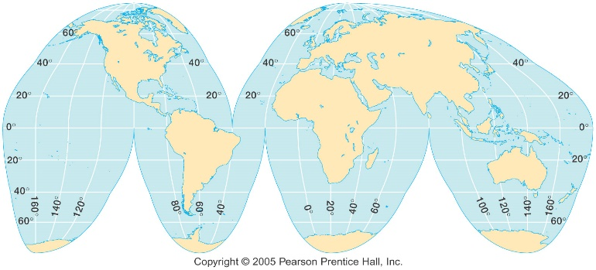

- What is the main advantage of the type of map projection shown above?

- What causes the changing of seasons throughout the year?

Unit 2: The United States and Canada
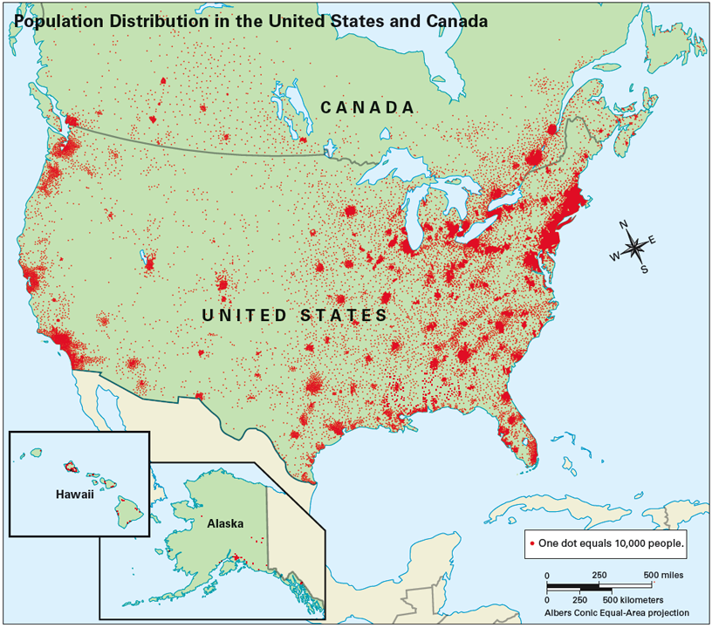
- The dark places on the map above are best defined as which of the following?

- Which term best describes people coming TO the United States FROM other countries to start new lives? Which term best describes people going TO other countries FROM the United States?

- What is the difference between push and pull factors?

- The United States and Canada fill _____ of the land surface of the Earth.

- If the United States is spending more on imports than it earns in exports, what is the result? How about if the United States is exporting more than it is importing, what would that result be?

- Why have the Appalachian Mountains experienced far greater erosion than the Rocky Mountains?

- Which oceans border the United States and Canada?

- What countries are involved in the North American Free Trade Agreement (NAFTA)?

- Why do 90% of Canadians live on only 10% of the land?

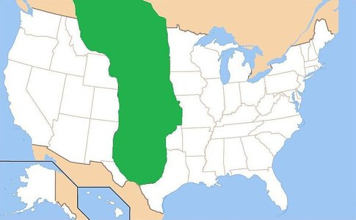
- The area shaded on the map represents what region of the United States?

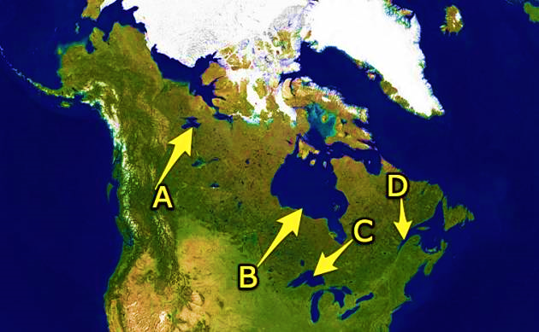
- Identify the letter that is pointing to the Great Lakes on the map.

Unit 3: Latin America
- What language do the majority of Latin American countries speak? What is the official language of Brazil?

- Area of grassland and rich soil that is used for cattle and wheat.

- What is the name of the river that forms the border between the United States and Mexico.

- Step-like fields cut into hillsides and mountains that allow crops to grow on steep land and cuts down on soil erosion.

- The Treaty of Tordesillas was an agreement between these two countries:

- The cutting down and clearing away of trees.

- What are the organizations that bring billions of dollars of illegal drugs into the United States?

- What major mountain range is located in South America?

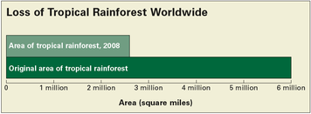

- According to the graph above, what happened to the size of the rain forest from its origination to the year 2008?

- What is the difference between a tropical storm and a tropical cyclone?

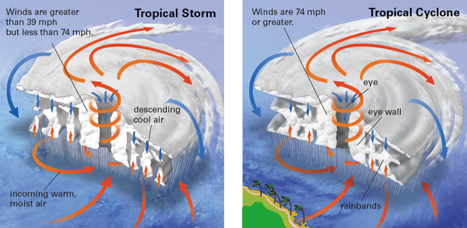
4
3
Unit 4: Europe and Russia
- A force that divides people and countries.

- Define centripetal force.

- How has the European Union (EU) promoted economic cooperation across Europe?
  - it has reduced or eliminated trade barriers
  - it has banned imports (goods from other countries)
  - it has raised workers’ salaries
  - it has ended business competition
- How is the EU able to have an open border policy among different nations?
  - developed a plural society
  - created a common form of money
  - eliminated all cultural differences
  - established a common defense organization
- What mountains form a border between Spain and France?

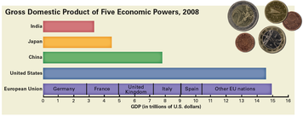
- Which of these statements is best supported by the information in the graph above?
  - The EU produces fewer goods and services than China.
  - The EU trades more with the US than with India.
  - The EU has almost the same economic power as the US.
  - The EU has a higher GDP than India, Japan, and China combined.
- Which of the following best describes the Northern European Plain?
  - flooding prevents the land from being cultivated
  - a lack of pesticides results in a low production
  - air and water pollution have destroyed the land
  - a variety of crops are produced in abundance
- Europe has 5 major peninsulas. What can you assume from this fact?
  - over sea/ maritime trading is important
  - plant and animal life are scarce and uniform
  - trade is difficult because of the terrain
  - written language was first developed here
- Which body of water is the deepest and oldest in the world, is one mile from the surface to the bottom at the deepest point, is 400 miles long, and holds 20% of the world’s fresh water?

- A region in Russia known for rigid temperatures and many natural resources.

- Out of the all the bodies of water discussed in Europe and Russia, which one is the best example of overuse of water in the region?

Unit 5: Africa
- Which is the central purpose of South Africa’s apartheid policy?

- What is the major difference between the Sahara and the Sahel?

- How has the Employment Equity Act affected job opportunities in South Africa since 1998?

- The __________ is the longest river in the world.

- This insect is the cause of Africa’s sleeping sickness.

- Where are the majority of Africa’s tropical rain forests located?

- Much of the poverty and violence of Africa during the 20th century is a direct result of __________.

- Why did apartheid hurt Africa’s economy?

- Which statement below is best supported by the graph?

  - South Africa is a developed country.
  - South Africa is a multiracial country.
  - South Africa is a democratic country.
  - South Africa is a mostly urban country.
- Identify the various ways an oasis can be formed.

Unit 6: Southwest Asia
- Why do water projects cause political problems in Southwest Asia?

- An area in the desert where water is found is known as a(n) __________.

- What city is recognized as the holy city to Christians, Muslims, and Jews?

- What is the purpose of a refinery?

- Why is oil considered a non-renewable resource?

- What is the process of how oil is formed?

- How is oil distributed among countries of Southwest Asia?

- Define renewable energy source.

- What is the major goal of the Organization of the Petroleum Exporting Countries (OPEC)?

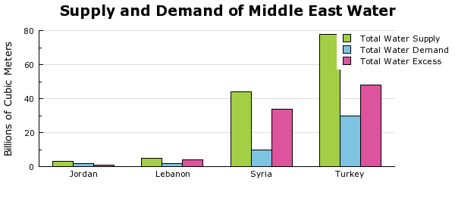
- According to the chart above, which country would be MOST likely to face a water crisis?

  - Jordan
  - Lebanon
  - Syria
  - Turkey

- According to the chart above, which country would be MOST likely to export water?

  - Jordan
  - Lebanon
  - Syria
  - Turkey

- How have wealthier, more urbanized countries like Saudi Arabia dealt with the lack of freshwater?

Unit 7: Monsoon Asia
- If you were traveling from India to China, what major landform would be an obstacle?

- What benefits is the Three Gorges Dam expected to provide?

- What term best describes hiring someone outside of a company to do work that was once done by the company’s own workers?

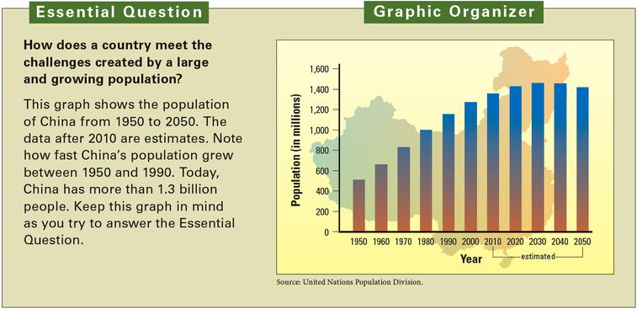

- Which statement about China’s population is best supported by the bar graph above?
  - it peaked between 1990 and 2000
  - it will begin to decline after 2010
  - it will continue to grow until 2050
  - it doubled between 1950 and 1990
- What was the main goal of China’s one child policy?

- Identify a comparative advantage that attracts foreign companies to the United States?

- Globalization has led to a rapid increase in which of the following?

  - water stress
  - international trade
  - transboundary pollution
  - arithmetic population density

- China looks to Japan for foreign investment and technology. Japanese consumers buy many goods made in China. This is an example of

- What nation contains both the Ganges and Indus River?

- Which religion do most people in India belong to?

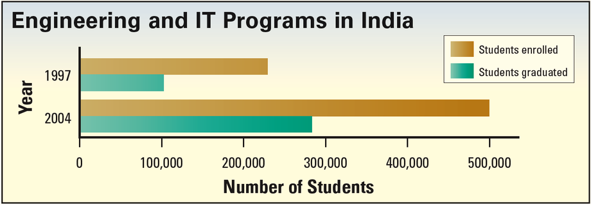
- According to the graph, how did technical and IT programs in India change between 1997 and 2004?
  - twice as many programs offered IT classes
  - the number of women who graduated from IT programs about doubled
  - the number of students enrolled in IT programs about doubled
  - twice as many IT students went to other countries to study
Unit 8: Oceania and Antarctica
- What happened to the Aborigines as more settlers arrived from Britain and France?

- What is the definition of an ice shelf?

- According to the theory of global warming, which part of the Earth is growing warmer over time?

- Which of the following best describes what the greenhouse effect does?

- Global warming is predicted to lead to all of the following EXCEPT:

  - rising sea levels
  - expanding ice caps
  - widespread crop failure
  - newly endangered species

- Scientists who doubt the global warming theory support their view by pointing out that some

- What do scientists study in Antarctica to learn about the climate of the earth from thousands to millions of years ago?

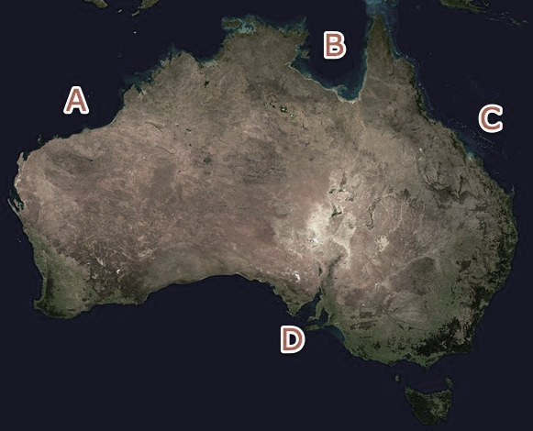
- Which letter represents the area known as the Great Barrier Reef?
  - “A” is the location of the Great Barrier Reef
  - “B” is the location of the Great Barrier Reef
  - “C” is the location of the Great Barrier Reef
  - “D” is the location of the Great Barrier Reef
- Australia’s interior contains very few population centers. Why is that?

- In which part of Australia would you expect to find a tropical climate?

  - northern
  - southeast
  - southwest
  - western

- The term Aborigines refers to the native inhabitants of which country?

- What do you call the sparsely populated are of the Australia interior?

- How many people live in Antarctica permanently? (This does not count researchers who come and go throughout the year!)

- Which mountain range runs down the east coast of Australia?

- How do the mountains in Australia impact the climate?

- According to the continental drift theory, which physical process brought Australia to its present position?

- What is the difference between a threatened species and an endangered species?

- What caused the ozone to develop?

- How are continental islands different from other types of islands?

- How do desalinization plants help islanders meet their water needs?

