**Financial Institutions**

**Milestone Exam Practice**

**SSEPF1a) Coupons, "buy-one, get-one free" deals, mail-in-rebates, sales, and discounts are**

1. positive incentives encouraging people to spend money.
2. negative incentives encouraging people to spend money.
3. positive incentives discouraging people from spending money.
4. negative incentives discouraging people from spending money.

**Essential Question 1**

What are financial institutions, and what three primary purposes do they serve?

**Financial institutions are companies engaged in the business of dealing with financial and ____________________ transactions such as deposits, loans, investments, and currency exchange.**

**Examples of financial institutions**

1. Commercial ____________________ are financial institutions that offer checking and savings accounts, receive deposits of money, extend credit by providing loans.

a. Interest ____________________:

interest the bank charges them to borrow money

b. Interest ____________________:

interest the bank pays them for the use of their money

2. ____________________ unions are cooperative associations that serve only their ____________________.

a. They offer checking and savings accounts, as well as grant loans.

b. Interest rates on loans are usually ____________________ at a credit union than at a commercial bank but you must be a member of that credit union (involves an annual fee).

**Purposes of Financial Institutions**

Banks and other financial institutions primarily serve to:

1. offer checking and savings accounts to customers

2. take deposits

3. provide loans

**Banks, the FED, and Fractional Reserve Banking**

1. ____________________ Reserve Banking is when banks hold only a small portion of deposits to cover potential withdrawals and loans the rest of the money out.

2. Banks make money through ____________________!!!

3. The Federal Reserve (FED) is the U.S. ____________________ bank, which serves to:

a. Regulate the Nation’s ____________________ supply and

b. Oversee all Financial Institutions

4. If we all went to the bank to withdraw our money at the same time it would create a BANK RUN!

5. One tool of the FED to control the money supply is called the ____________________ Ration Requirement (RR), which mandates all banks to hold a certain percentage of cash in the vault. **(RR is the RESERVE REQUIREMENT**)

6. Banks can loan out the ____________________ Reserves with interest!

7. The current RR is 10% (0.1), meaning banks can loan out ____________________ of their money.

**The Money Multiplier**

The Money Multiplier (MM): calculates how banks increase the money supply by loaning out money that has been ____________________.

Formula for the MM = 1 / RR

**MM Practice**

Bayley deposits $500 to Chase Bank. How much will this increase the money supply if the RR is 10%? (Hint: the RR is 10%, then it is 0.1)

Go ahead and solve!

Step 1: Calculate the MM 1/RR = 1/ 0.1 = ____________________

Step 2: Multiply the Deposit by the RR $500 x 0.1 = ____________________

Step 3: Subtract the calculated RR of the deposit $500 - $50 = ____________________

Step 4: Multiply the loanable amount by the MM $450 x 10 = ____________________

*What is happening here:* The RR is 10%, so the bank must hold back 10% of the deposit, which is $50. That leaves $450 for the bank to loan out, so once the MM of 10 is multiplied by the loanable amount, $450 becomes $4,500 of “new” money.

* Be sure to copy down the steps of the MM Practice Questions from class!

**Milestone Exam Practice**

**SSEPF2a)** The financial institution that generally charges the LOWEST rates on loans is a

1. finance company.
2. commercial bank.
3. credit union.
4. savings and loan.

**Financial Institutions and Investments**

**Essential Question 2**

Why should you invest your money, and what is the relationship between financial risks and returns?

Why Invest Money

1. Retirement!

2. So your money is making an ____________________

3. Short-term purchases: buying a ____________________, college tuition, etc.

Note: Compound ____________________ is a key aspect of investing.



**Risk and Return**

1. It is a direct relationship

2. The riskier the investment, the ____________________ the rate of return possible.

3. However, the investor assumes a greater risk that a portion of or all of the money invested could be lost.

Ex: ____________________ are risky but returns can be high

Ex: Savings accounts and ____________________ are low risk but carry low returns

**Investments: Riskiest to Safest**

1. Stocks – shares in a company that an individual/organization purchases, giving that person /entity part ownership

* + Invest in riskier stocks when you’re younger and less risky as you get closer to retirement age

2. Bonds – loans (I.O.U with fixed interest rate) to either a company or the government

3. Mutual Funds – pool money from a number of investors to buy a range of investments: stocks, bonds, short-term money-market instruments, or other securities (diversified portfolio)

4. Certificates of Deposit (CDs) – timed savings account that pays higher interest rates than savings but invokes penalties for early withdrawal

5. Savings Account – Income that is not spent on consumption but is put aside (very low interest rate; more of a holding account than anything)

**Milestone Exam Practice**

**SSEPFc)** Based on the graph, which of these statements is TRUE?

1. Investors who want low risk should invest in bonds.
2. A certificate of deposit is a riskier investment than a bond.
3. Money in a stock-based mutual fund grows as fast as in a bond.
4. Money in stocks have both high risk and high potential return.

**Credit 101**

**Essential Questions 3**

1. Is credit good or bad for your personal finance?

2. What are some factors that can affect your credit?

3. Do you believe that owning a credit card is good or bad or you? What about 2 or 3 credit cards?

**Credit, Principle, and Interest**

1. Credit- an agreement under which a buyer receives goods and services at the present time in exchange for a promise to pay for them at a ____________________ time.

2. Interest- the amount of money that a lender charges a borrower in exchange for the use of their money

a. The cost of credit is ____________________

b. Always look at the INTEREST RATE before taking out a loan, specifically the ____________________ (annual percentage rate)

c. ____________________ rates drive the economy (REMEMBER THAT!!!)

3. Principal- the ____________________ amount o money that has been borrowed

**Credit Cards vs Debit Cards**

1. Using a credit card means you are borrowing money from the credit issuers as a loan that you will pay back with interest.

2. ____________________ is the annual percentage rate that shows the total cost of the loan, including compounding and other fees.

3. Credit card APRs vary (usually between 10% - 20%) and can dramatically increase if you are late or miss a ____________________

4. When you use a debit card, you are using your own money from your banking account, so there is no ____________________.

5. When you use a debit card, you must have the money in your bank account, or you could be penalized with bank fines.

**Simple and Compound Interest Rates**

1. Simple interest- is a rate that is applied only to the value of the ____________________

a. (simple interest grows SLOWLY)

b. Interest = Principal x rate x terms (I = P x R x T)

c. Term is how long you will take to pay the loan back

2. Compound interest- is interest applied to BOTH the principal and the ____________________

a. You pay interest on interest; so compond interest grows FAST

b. Interest = Principal x (1 + rate)^term – Principal

**What Factors Affect Credit Worthiness**

1. Credit History
   * ____________________ is the amount of money that you owe a lender from borrowing
   * Credit score is a number based on your history as a borrower; bad debt damages your credit score
   * Credit worthiness is when a lender uses your credit score to determine what type of loan you can receive
     + If your credit score is high, lenders will loan you money at a lower interest rate (740-850)
     + If your credit score is low, lenders will loan you money at a higher interest rate (599-499)
2. Job/Income
   * How much money you make determines loan ____________________
   * Must be able to prove that you have the ability to pay back the loan
3. Debt-to-Income Ratio – total monthly debt obligations / amount of total monthly income
   * Lower the number the better and it should never exceed 33
   * Amount you pay toward your debt shouldn’t exceed 33% of you monthly income; if so, you’ve over-extended yourself and are living above your ____________________
4. Age
   * Very young means you don’t have much of a credit history & very old means your ability to pay back the loan may be suspect
5. Education
   * The higher your ____________________ level, the more credit lenders make available to you
   * Remember the importance of investing in Human Capital???

**Milestone Exam Practice**

**SSEPF4c)** Ricardo decides to invest $10,000 over a 20-year period. Should he put his money in an investment that has a simple interest rate or compound interest rate?

1. Simple interest earns more because simple interest always has a higher rate.
2. He would earn the same amount, as these are different terms for the same thing.
3. Simple interest earns more because the interest is determined annually on the original amount.
4. Compound interest earns more because the amount on which interest is paid increases over time.

**Taxes and Personal Finance**

**Essential Questions 4**

1. What group is most negatively affected by unanticipated inflation?

2. How does the federal government generate revenue?

3. What is the difference between progressive, proportional, and regressive tax structures?

4. What group is most negatively impacted by a sales tax? Why?

**Facts to Know about Inflation** (Because it is on the Milestone and you need to know this for Life 101)

1. Inflation – general ____________________ of all price levels (in other words, everything cost more!)

2. Inflation decreases the purchasing power of the dollar, thus ____________________ the value of the dollar (life becomes more expensive)

3. Long periods of unanticipated inflation favor ____________________ over Creditors

4. Inflation has the most negative impact on retirees living on a ____________________ income (like social security)

a. Think, people on fixed incomes receive the same check amount, but now everything is more expensive for them to purchase

b. COLA (Cost of Living Adjustment) is designed to protect those living on a fixed income from anticipated inflation

**Taxes- Where did our income go?**

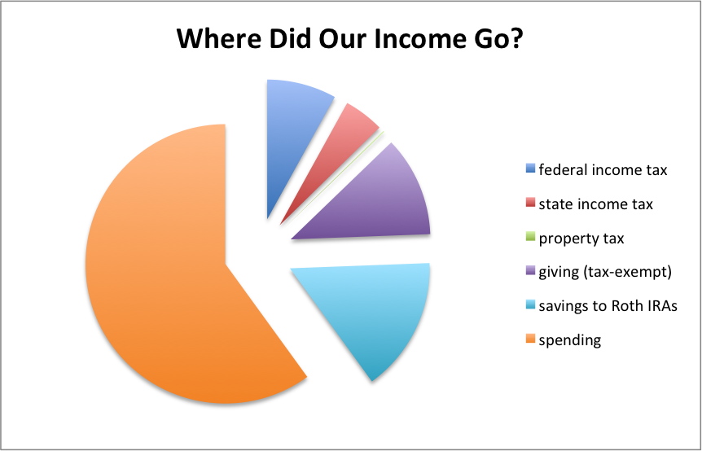

**Government Revenue and Fiscal Policy**

1. Fiscal Policy is the Gov’t

a. Taxing and **KNOW THIS!!!!!!!**

b. Spending

2. Tax is a mandatory payment to a local, state, or national gov’t

3. Primary means of Gov’t Revenue is derived from ____________________!!!

4. Principles of Taxation:

a. Benefits-Received VS.

b. Ability-to-Pay

5. Criteria for Taxes:

a. Equity (____________________),

b. Simplicity, and

c. Efficient

6. Taxable income is the amount of income subject to taxation by the state & federal gov’t after ____________________ & deductions

7. Incidence of a tax is the final burden of that tax (impact of the tax on a ____________________)

Ex: When gov’t taxes oil companies, the oil companies raise the prices at the gas pump, so consumers are the ones who actually pay the increased taxes

**Three Tax Structures** **KNOW THESE!!!!!**

1. Progressive Tax

a. Percentage of income paid in taxes increases as income ____________________

b. The more you make, the more they take!

c. The wealthy bear the burden

d. Ex: United States Federal Income Tax

2. Regressive Tax

a. Percentage of income paid in taxes ____________________ as income increases

b. More you make, the less they take

c. The poor bear the burden

d. Examples: Sales tax, sin taxes (alcohol, tobacco, and lottery), and Excise Tax on gasoline

3. Proportional Tax

a. Percentage of income taxes remains the same for all income levels (some like to call it a ____________________ tax)

b. Everyone pays the same %

c. Usually also considered to be a ____________________ tax

* Sales tax- a general state or city tax levied on a product at the time of ____________________
  + Sales tax affects ____________________ income groups more than higher income groups, so it is both a ____________________ and regressive tax

**Property Taxes**

1. Property Taxes (millage rate) – ad valorem tax paid on the value of a ____________________ (real estate) to the city/county for ownership

2. Property taxes are mainly used by municipalities for repairing roads, building & funding public schools, and other public goods and services provided by the local gov’t

3. Property taxes will vary from place-to-place and year-to-year based on estimated property ____________________, wealth of the city or county, and needed or projected gov’t public projects

**Tax Incentives**

1. Tax incentive is the use of taxes to ____________________ or discourage certain economic behaviors, such as tax credits or rebates for buying hybrid cars, recycling, green energy companies, business moving into economically depressed neighborhoods, etc.

2. SIN taxes are designed to raise revenue & lower ____________________ of a good or service the gov’t deems as harmful (alcohol & tobacco)

3. Sin taxes are usually ____________________

**The Federal Income Tax**

**Essential Question 5**

Why is the individual federal income tax so important to fiscal policy, when was it enacted, and how is it collected?

**Federal Income Tax**

1. It is the biggest source of federal taxes (45%)

2. The 16th Amendment (1913) created the deferral income tax (thanks President Wilson!)

3. Pay-as-you-earn: Payroll tax is deducted from a paycheck withholding before the worker receives it and sent to the IRS (internal Revenue Service)

4. Tax Returns- are due by April 15th (form 1040 declares income and ____________________ income)

5. The federal income tax is a progressive tax! (The more you make, the more they take)

6. Indexing- is a revision of tax brackets to prevent workers from paying more taxes due to ____________________ and keeps them from being pushed into a higher tax bracket

**Progressive Federal Income Tax Bracket**

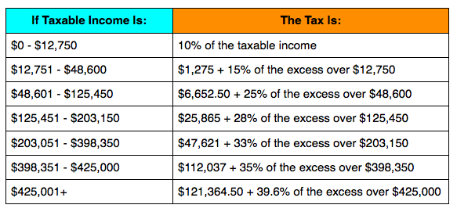

1. Tax bracket – scheduled rate at which you are taxed based on your annual income

2. Marginal tax rate – tax rate that applies to your last unit of currency

3. Taxable income – person’s gross income minus exemptions & deductions

4. Exemptions – set amounts subtracted from your gross income to reduce amount of taxable income

EX: Personal exemptions & dependents ($3,800 for each exemption)

5. Deductions – amounts that you can subtract from your gross income

EX: Interest on home, student loan, charity, religious giving

**Milestone Exam Practice**

**SSEPF3b**) Most economists believe that a sales tax increase affects which group the MOST?

1. hourly workers
2. salaried workers
3. people with low incomes
4. people with the highest range incomes

**Insurance**

**Essential Questions 6**

1. What are the various types of insurance and how does insurance protect you from financial loss?

2. What is the purpose of purchasing insurance?

3. Can you name a few types of insurance?

4. Do you believe that it is important to have health insurance? What about life insurance? Why or why not?

**Five Types of Insurance**

* Insurance – money paid to an insurance company for assurance that, if what they value is lost or damaged, the ____________________ company will pay for their loss

1. Automobile – covers cars (vehicles)
   * **Costs-determined by the type of car, driver experience, driver age, driver’s education/grades, driver’s city of residence, mileage driven**
   * Paid monthly, every six months, quarterly, or yearly
   * Different prices can be quoted by different car insurance companies. Shop around!
2. Health – covers doctor visits, prescriptions, and other ____________________ costs
   * Costs-determined by the health coverage you pay for and choose
   * Paid monthly
   * Different prices determined by different plans for different services/copays/coverage
3. Life – covers someone’s life
   * Costs-determined by the age of the insured and amount to be paid at ____________________
   * Paid premium monthly
4. Disability –covers income if you are unable to ____________________
   * Costs- determined by salary, and benefit if you are out of work
   * Paid monthly premium
5. Property – covers property, land, homes
   * Costs-determined by how much the property is worth, credit score, and ____________________

**What are premiums and deductibles?**

1. Premiums- monthly payment for ____________________

2. Deductibles- dollar amount of expenses that must be paid out of pocket before an insurer will pay any expenses for loss or liability (**MONEY PAID BY YOU BEFORE INSURANCE PAYS ANYTHING**)

a. If you pay a high premium, then your deductible will be ____________________

b. If you pay a ____________________ premium, then your deductible will be high

**Milestone Exam Practice**

**SSEPF5b**) An insurance policy with a higher premium MOST LIKELY has

1. a lower deductible.
2. no liability limit.
3. a higher deductible.
4. a lower liability limit.

**Importance of Human Capital**

1. Human Capital

a. Significance of Investing in education, training, and skill development

b. The more education/training the more ____________________ you will make

c. If you possess a skill no one else does, you will be able to command more money for that skill, and you will have job ____________________

2. What skills are needed to be successful in the workplace? (see the slide giving a broad list)