Unit 2: Personal Finance, SSEPF1-6 **Class Copy
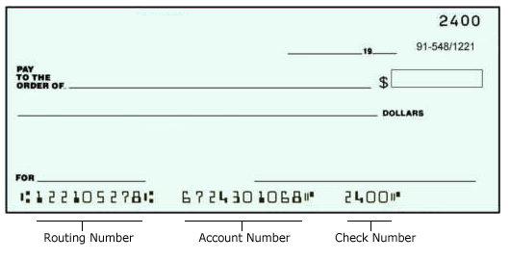
What is on the check?
Your bank routing number is a nine-digit code that’s based on the U.S. Bank location where your account was opened. It’s the first set of numbers printed on the bottom of your checks, on the left side. You do not use your routing number for many transactions, but you will need it when you set up direct deposit for your paycheck.
Your account number (usually 10-12 digits) is specific to your personal account. It’s the second set of numbers printed on the bottom of your checks, just to the right of the bank routing number. You can also find your account number on your monthly statement.
Check number- write it down in your checkbook ledger.
Write the amount out in dollars and cents. You can write “zero cents” or “and 0/100.” You draw a line so that no additional amount can be added on to the check. Try not to leave any space!
Who is the check for?
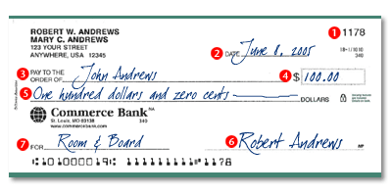
Add a brief note for what the check is for.
Do not sign a blank check! Do not endorse a check any earlier than you need to!

Checkbook Activity: Complete a checkbook ledger for the following expenses. Attach checks to your ledger before turning this assignment in. Your starting balance is $350.
Date | Purchase/Transfer | Deposit
2/12 | Debit card- Walmart $29.95
2/12 | Debit card- Chevron gas $19.50
2/12 |  | Paycheck $208.77
2/13 | Debit card- movie theater $25.00
2/14 |  | Valentine’s Day gift from Grandma $50.00
2/14 | Check for car insurance $250
2/14 | Debit card- Texas Road House $63.00
2/14 | Debit card- Dairy Queen $9.85
2/15 | Debit card- Waffle House $7.65
2/16 | Check for Herf Jones/graduation $100.00
2/17 |  | $75.00 from Grandma to help with graduation items
2/18 | Debit card- Chick-fil-a $6.50
2/19 | Debit card- Subway $6.74
2/20 | Transfer $30 to Savings Account

Example of checkbook ledger:
Write check # Date Description Payment/Transfer amount Deposit amount Balance

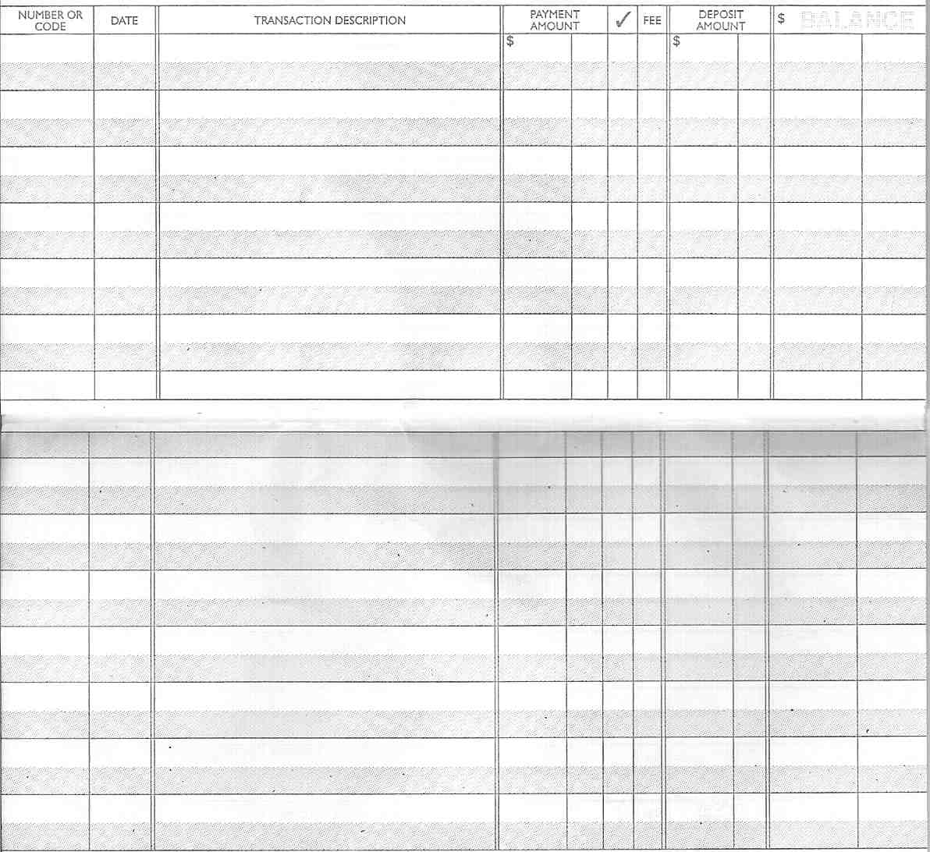
Side Notes: When a check is cashed and money has been withdrawn from your account, write a check mark in the column next to the payment amount to record that the check has cleared. If you use your debit card and you are charged a fee, or if there is any other fee involved, write the amount in the fee column. After you subtract payments or add deposits, record the remaining balance in the grey box in the balance column to keep track of how much money you have in your checking account.

